Gaeltacht Youth Work Pilot Initiative – Call For Service
Introduction:
Mayo, Sligo and Leitrim Education and Training Board (MSLETB) is seeking an organisation with experience of providing youth services to young people to deliver a dynamic engaging youth service to young people in the Irish Language in the Gaeltacht Mhaigh Eo Thuaidh (Iorras).

The organisation MSLETB is seeking should:
- Exemplify good practice in relation to vision, methodologies, governance, compliance, programme design, delivery and evaluation of youth services
- Be committed to supporting the development of the Irish language amongst young people in Gaeltacht areas of Gaeltacht Mhaigh Eo Thuaidh (Iorras) and its environs
- Be prepared to collaborate closely with the local language planners in co-designing and supporting the implementation of the project workplan.
- Demonstrate an understanding of the Irish language and the Irish Language planning process
- Be experienced in working with young people aged 8-24 years with complexity of needs, using a non-formal educational methodology
- Operate in an out-of-school setting, including evenings, weekends and school holidays

- Understand the nature and needs of young people living in Gaeltacht communities and its environs and offer appropriate responses
- Be committed to on-going sharing of learning and collaboration and be willing to participate in an action research evaluation model.

Background:
This initiative is a pilot project envisaged for a minimum of a three-year period, subject to funding and evaluation and is co-funded by the following stakeholders:
- Department of Children, Equality, Disability, Integration & Youth (DCEDIY) / MSLETB.
- Gaeilge Iorrais
- Muintearas
MSLETB will function as an intermediary body for the funding organisations outlined above with full responsibility for oversight and governance of this project in line with the Code of Governance for ETBs and relevant department circulars including Department of Public Expenditure, NDP Delivery and Reform Circular 13/2014.

Education and Training Boards (ETB)
Education and Training Boards (ETBs) have a role in the development, implementation and strengthening of policy and service provision for children and young people, including youth work provision, which will achieve better outcomes for children and young people. This is in line with the statutory responsibility of the ETBs in matters of youth work policy implementation and additionally covers the ETB role in the broader policy objectives of DCEDIY as it relates to youth policy.

The Education and Training Boards Act, 2013 states that the functions of ETBs with regard to youth work are to:

- Support the provision, coordination, administration and assessment of youth work services in its functional area and provide such information as may be requested by the Minister for Children and Youth Affairs in relation to such support; and assess whether the manner in which it performs its functions is economical, efficient and effective.

The Education and Training Boards Act goes on to state (Section 10(6)) that “youth work” has the same meaning as it has in the Youth Work Act 2001.

Department of Children, Equality, Disability, Integration and Youth (DCEDIY)
The DCEDIY is the principal government department to whom ETBs report to in relation to their youth work functions. It has a mandate in relation to policy and service provision for children and young people. The Department comprises a number of interrelated strands, including the direct provision of universal and targeted services, and working to achieve the harmonisation of relevant policy and provision across Government so as to improve outcomes for children, young people and families.

Údarás na Gaeltachta
The overall objective of Údarás na Gaeltachta is to ensure that Irish remains the main communal language of the Gaeltacht and is passed on to future generations.
The Údarás endeavours to achieve that objective by funding and fostering a wide range of enterprise development and job creation initiatives and by supporting strategic language, cultural and community-based activities.
Established in 1980, Údarás na Gaeltachta is the regional authority responsible for the economic, social and cultural development of the Gaeltacht.

Langauge Planning Process
Gaeilge Iorrais – Coiste Pleanála Teanga i Limistéir Pleanála Teanga Mhaigh Eo Thuaidh (MET) (Plean Teanga Gaeilge Iorrais, Ní Dhúda, 2018)
Plean Teanga Gaeilge Iorrais le fáil anseo ag : http://www.gaeilgeiorrais.ie/images/plean.pdf
Suíomh Gaeilge Iorrais anseo: http://www.gaeilgeiorrais.ie/index.php
Gaeilge Iorrais (Plean Teanga Gaeilge Iorrais, Ní Dhúda, 2018)
Under Acht na Gaeltachta 2012 every Gaeltacht community must prepare and implement a language plan to support and develop Irish language use in their area.
Gaeilge Iorrais is responsible for overseeing this process in Maigh Eo Thuaidh (North Mayo Gaeltacht area).
It is the vision of Gaeilge Iorrais, in co-operation with the local community and local organisations, to gradually increase and support the daily usage and knowledge of the Irish language in the North Mayo Gaeltacht.
Gaeilge Iorrais endeavours to achieve that objective through the use of a seven-year community language plan (2018 - 2024), which aims to improve ability in, and increase usage of the Irish language in the education system, in youth activities, in the household, and as part of public, commercial, social and recreational activities.
Muintearas
Muintearas activities focus on early childhood education; training and mentoring; social enterprise; education; community development and youth work.
Muintearas administers the Gaeltacht Summer Camps program and the Language Assistant Scheme on behalf of the Department of Tourism, Culture, Arts, Gaeltacht, Sports & Media. Muintearas offers youth work programs in all Gaeltacht areas by supporting a network of youth clubs, which have been established by Gaeltacht communities for many years.
Location & Overview of Maigh Eo Thuaidh
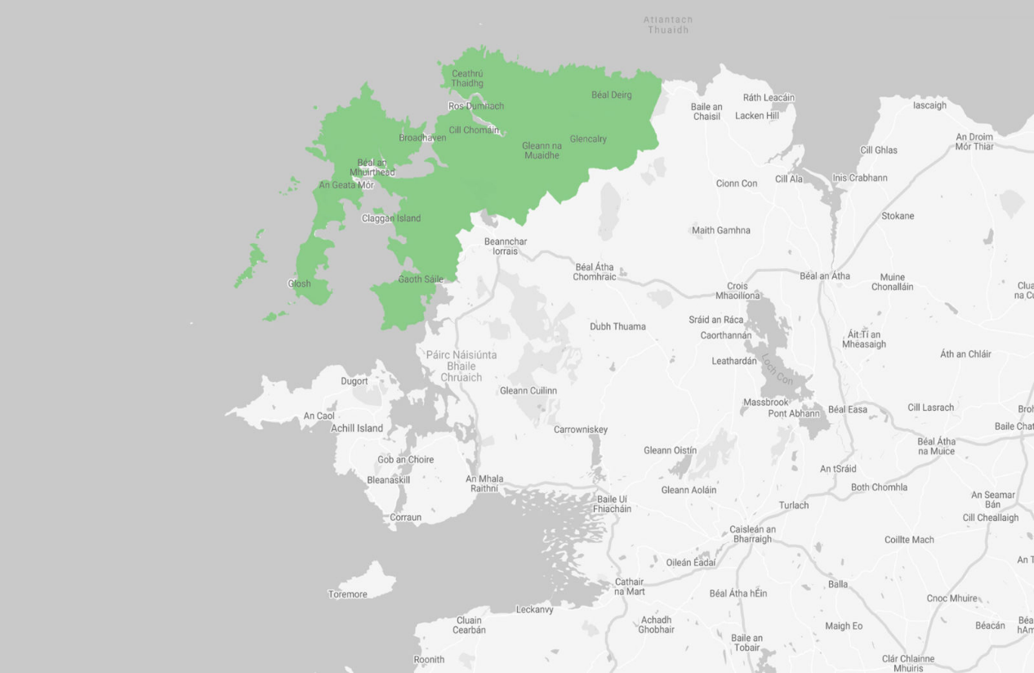
Maigh Eo Thuaidh covers an area of 584.43km², which spans from Fód Dubh to Béal Deirg, Ceathrú Thaidhg to Dumha Thuama and has a population 7,330. This represents 6.9% of the total Gaeltacht population in the county. Under Acht na Gaeltachta 2012 Maigh Eo Thuaidh, County Mayo includes the following electoral division areas (EDs): Béal an Mhuirthead, Cnoc na Lobhar, Cnoc na Ráithe, An Geata Mór Theas, An Geata Mór Thuaidh, Gleann Chaisil, Na Monga, Barr Rúscaí, Béal Deirg Mór, Cnoc an Daimh, Gleann na Muaidhe and Moing na Bó and part of the electoral division area of Guala Mór which consists of the townland of Troiste.
Maigh Eo Thuaidh Gaeltacht is notable as an area of outstanding natural resources. However, a key feature of the area that impacts economic, social and cultural lives of its residents is that of a much-dispersed population across small scattered settlements in remote and rural terrains. This geographical challenge is further compounded by distance from supports and services, poor transport links and a population dependent for employment on marginal farming, the service industry in and around Béal an Mhuirthead and the seasonal tourism industry. Many residents of the area, including young people, have to travel to access employment opportunities in urban centres across County Mayo including Ballina and Castlebar, both of which can incur a travel time of between 1.5 to 2 hours depending on the mode of transport – public bus service or private car.
Live register figure for May 2024 indicates that 304 persons (4%) were registered, of which 26 were under the age of 25 (CSO, LRMO7). While Live Register figures are on par with the national rate (4%), the distinctive feature of the Live Register figures for Maigh Eo Thuaidh Gaeltacht is the consistency of unemployment/underemployment over the previous 6+ months, pointing to an embeddedness of joblessness in the area.
The Maigh Eo Thuaidh Gaeltacht has constantly been recorded as experiencing deprivation. While some areas have improved between 2016 and 2022, all EDs in the area are recorded as disadvantaged or marginally below average (with the exception of one ED) (Table 1). Even within the EDs there are deep pockets of disadvantage ranging from -21.68 to -21.07.
2. Overview of the Irish Speaking Population in Maigh Eo Thuaidh Gaeltacht
Maigh Eo Thuaidh Gaeltacht has a population of 7,330 with 3,909 of Irish speakers (53%). The regions of Ceathrú Thaidhg / Ros Dumhach 'Rossport' and Eachléim are the strongest in the area in terms of the Irish language and its fluency. The population of the area and Irish Speakers within each EDs are presented in Table 2 below.
Area | Population | Number of Irish Speakers
Béal Deirg Mór | 150 | 65
Barr Rúscaí | 99 | 56
Gleann na Muaidhe | 209 | 99
Na Monga | 223 | 109
Cnoc na Lobhar | 768 | 365
An Geata Mór Theas | 881 | 606
An Geata Mór Thuaidh | 1,014 | 554
Cnoc an Daimh | 314 | 245
Moing na Bó | 249 | 146
Cnoc na Ráithe | 695 | 337
Béal an Mhuirthead | 2,143 | 1,028
Gleann Chaisil | 499 | 230
Guala Mór | 86 | 69
Total | 7,330 | 3,909
Table 2: Maigh Eo Thuaidh Gaeltacht Population & Irish Speakers (by ED)
Source: CSO, 2022 (Table F8067)
The youth population of 2,047 (0 - 24 years) of the area accounts for 27.9% of the population of the Maigh Eo Thuaidh Gaeltacht which is presented in Table 3 by age category:
Age Category | Population
0 - 4 | 405
5 - 9 | 449
10 - 14 | 467
15 - 19 | 446
20 - 24 | 280
Total | 2,047
Table 3: Maigh Eo Thuaidh Gaeltacht: Youth Population by Age Category
Source: CSO (SAPMAP 2022)

Education provision to the youth population includes Gaeltacht primary schools located in Ceathrú Thaidhg, Ros Dumhach, Eachléim, Gleann na Muaidhe, Dumha Thuama, Corrchloch agus Poll a' tSomais. The Gaelcholáiste in Ros Dumhach (post-primary school in Rossport) and two other secondary schools in Belmullet that are part of the Irish language scheme (contain a percentage of 'scoláirí scéime' or Irish language scheme students - who undertake part of their education through Irish).
However, the limited speaking of Irish outside of the education system is apparent. Table 4 below highlights the variations in the use of the Irish language in and outside the school system.
Area | Speak Irish in the Education System | Never Speak Irish Outside the Education System
Béal Deirg Mór | 11 | 11
Barr Rúscaí | 15 | 10
Gleann na Muaidhe | 21 | 10
Na Monga | 34 | 8
Cnoc na Lobhar | 61 | 59
An Geata Mór Theas | 134 | 42
An Geata Mór Thuaidh | 182 | 81
Cnoc an Daimh | 40 | 7
Moing na Bó | 31 | 14
Cnoc na Ráithe | 74 | 58
Béal an Mhuirthead | 249 | 180
Gleann Chaisil | 62 | 42
Guala Mór | 15 | 10
Total | 929 | 532
Table 4: Maigh Eo Thuaidh Gaeltacht: Irish Speakers in/outside the Education System
Source: CSO Table F8067

Irish Language- Irish Constitution and Strategy
Article 8 of the Irish Constitution establishes the status of languages in Ireland:
- The Irish language (Gaeilge) is the first official language.
- The English language is recognized as a second official language.
This constitutional recognition ensures that Irish citizens have the right to use either language when dealing with government institutions and services.
Article 30 of the Irish Constitution permits the public to conduct its business – and every part of its business – with the state solely through Irish.
The Official Languages Act 2003 and subsequent amendments reinforce this constitutional right by requiring public bodies to provide services in both Irish and English.
The most recent amendment, the Official Languages (Amendment) Act 2021, aims to enhance Irish language proficiency in the public service and ensure services are provided in Irish in Gaeltacht areas.
In summary, the Official Languages Act and constitutional provisions outlined above affirm the entitlement of Irish language speakers to receive services in their native language.

20-year strategy for the Irish language (2010) states:
"The critical need to give life to the Irish language outside the classroom for the young people who study it in the formal education system is a widespread conclusion of language revitalisation efforts throughout the world. Fostering the creation of youth culture and identity, and their appropriate Irish language forms, involves providing opportunities for its natural use and creating ICT mediated networks of speakers. The education sector will work in partnership with relevant agencies in this regard." (p.12)
In relation to Language Planning in the Gaeltacht:
"Future State expenditure on the language in the Gaeltacht will be determined by reference to its linguistic impact and particular priority will be afforded to linguistic supports for families and young people so as to ensure the continued transmission of the language from generation to generation.
Particular emphasis will be placed on the promotion of an Irish language youth culture in the Gaeltacht, which will see further development of Gaeltacht youth services and a linkage through the Gaeltacht Summer Colleges with national youth organisations.” (p.21)
The Gaeltacht Act 2012 sets out the language planning system with the Language Plans approved by the Minister for the Gaeltacht. These plans include reference to the recruitment of Youth Officers to support youth engagement.
In this context MSLETB, Gaeilge Iorrais and Muintearas have collaborated together in developing this initiative to explore and establish how best to support Irish language Youth Work Provision in the Gaeltacht areas of Iorras.
Service Brief:
The approach offered by the successful organisation must have at its core the following elements:
- Coordinating a programme of events, activities and services with stakeholders and state agencies to ensure that there is a comprehensive and dynamic youth service for young people in the Gaeltacht in the Irish language.
- Focus on developing culturally appropriate interventions in response to the needs of the young people within the Gaeltacht areas identified above.
- Engage the children and young people (aged 8-24 years) in the co-design of the Project and the programmes on offer.
- Collaboration with Gaeilge Iorrais, Muintearas Teo and other relevant stakeholders, including UBU services and other youth organisations, to ensure youth participation on a regional and national basis.
- Engage with an action-research evaluation process to build capacity with young people, youth work practitioners and stakeholders to examine what constitutes effective youth work through the medium of Irish.
- Participate in training and networking events within the youth work and language planning sectors.
- Ensure adherence to best practice in youth work and comply with Children's First guidelines, as well as relevant best practice policies and guidelines within the youth work and Irish language planning sectors.
- Operate primarily on late evenings, on weekends and during school holidays.
Funding:
A budget of €64,042 per annum has been made available for each of the areas identified above for this new initiative. Organisations may submit applications for individual areas or both depending on their interests and capacity to deliver interventions in each area.

Selection Process for the New Project Preferred Provider
A Youth Work Service will be selected through the following selection process:
• Stage 1 – MSLETB publicly advertise the Scheme on the 4th March 2025 asking interested parties to apply according to the steps outlined in this Information Pack. The closing date for receipt of fully completed Submission Application Form is Wednesday 2nd April 2025.
NOTE: Only organisations who have fully completed the Submission Application Form and submitted the required eligibility documentation will be considered.
• Stage 2 – Analysis of Submissions received and shortlisting for interview process by MSLETB and funding bodies Muintearas and Gaeilge Iorrais.
• Stage 3 – Interviews conducted bilingually in both Irish and English consisting of a formal presentation by the applicant organisation will be scheduled for Thursday 1st May 2025.
• Stage 4 – Decision is reached by interview panel, further discussions may be held with selected preferred provider regarding their service offer and Steering Group requirements.
• Stage 5 – Once confirmed the successful Youth Service will be issued with a formal confirmation of their status as the provider along with an allocation letter. If required a Service Level Agreement will be issued and signed by the successful funded organisation and MSLETB. The Funded Organisation undertakes phase one of the New Youth Service, hiring staff, providing orientation training, securing premises etc. Performance Oversight & Engagement Framework will commence during this stage.
• Stage 7 – New Youth Service launch.
In compliance with the Data Protection Act 2018, the General Data Protection Regulation, and guidance from the Data Protection Commission, any personal data you give MSLETB in connection with this application will be kept securely and only used for the purposes of assessment (including shortlisting and interviewing), general administration, reporting and to fulfil our other legal obligations. When MSLETB no longer have any lawful basis for retaining it, it will be destroyed/deleted. Under the Freedom of Information (FOI) Act 2014, any information we receive in our dealings with you can potentially be released to the general public on request.
Details Stage 1: Return of Submission Application Form
Closing date for applications is Wednesday 2nd April 2025 and should be submitted electronically to MSLETB Youth Office at youthwork@msletb.ie
It is the responsibility of each respondent to ensure that the Submission Application Form reaches MSLETB before the deadline.
Details Stage 2: Analysis of Submissions received and shortlisting for interview process
Applications will be shortlisted in line with the following:
Eligibility Checklist:
- Received By Deadline
- Declaration completed
- Glacfar leis go ndéanfaí gnéithe den iarratas I nGaeilge agus go mbeidh se de chumas ar an eagraíocht cuid den próiseas agallaimh a dhéanamh trí Ghaeilge.
- Applicant is a youth service organisation
- Child Safeguarding and Health & Safety Policies Submitted
- Public Indemnity and Insurance Confirmed
- GDPR Policy Submitted

Assessment Criteria | Marks Available
Knowledge and Track Record of Youth Work Interventions including knowledge of the local area | 30%
Capacity to Deliver Project in Irish Language | 30%
Value for Money/Additionality including access to premises, equipment, volunteers and other resources | 20%
Capacity and ability to deliver on the operational and governance requirements | 20%

Details Stage 3: Interview
Interviews, conducted bilingually will consist of a formal presentation by respondents and are scheduled to take place on Thursday 1st May 2025. The selection of a preferred provider will be based upon assessment of both the Submission Application Form AND the interview process. Both the Submission Application Form and the interview will be marked under the 5 categories outlined above, namely:
- Knowledge and Track Record of Youth Work Interventions including knowledge of the local area
- Capacity to Deliver Project in Irish Language
- Value for Money/Additionality including access to premises, equipment, volunteers and other resources
- Capacity and ability to deliver on the operational and governance requirements

The formal presentation which is part of the interview process must address the 4 categories indicated in the scoring system.

Plean Teanga Seacht mBliana (2018 – 2024) do Limistéar Pleanála Teanga Mhaigh Eo Thuaidh (Ní Dhúda, 2018).
CSO, Census 2022
CSO Table F8067
MSLETB Meeting with Muintearas June 2024

