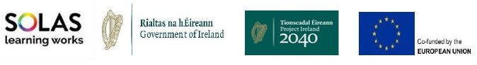
REACH FUND 2023

formally known as the
Mitigating Against Educational Disadvantage Fund

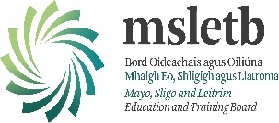

Application Form

Please answer all questions in this application form.
Projects to be completed by 24/11/2023)
If all documentation is not included, this will delay your application.
Introduction:
The aim of the Reach fund (formally MAEDF) is to provide funding to support educationally disadvantaged learners in accessing and participating in community education. It aims to increase the participation of disadvantaged learners, particularly those who are undertaking literacy and skills programmes. The fund has a strong focus on building the digital infrastructure of community education providers, including providing devices and software, and increasing their capacity to deliver learning. The fund was specifically designed to tackle inequalities and support access to community education and intended to address specific actions in the Adult Literacy for Life (ALL) Strategy to target funding on access to technology and devices, expand community access to wi-fi and broadband resources and to directly address unmet literacy needs.
Funding Categories:
1. Learner assistance fund - initiatives that will support learners to engage/participate in educational programmes Innovative green projects
- Participation of priority/target cohorts – projects focused on increasing participation in learning with target cohorts:
    - Long term unemployed
    - Young people (16+)
    - People with disabilities
    - Members of the traveller and Roma communities
    - Migrants and refugees
    - Women wishing to return to the labour market
    - Lone parents
- Equality Awareness: Events/awareness campaigns that contribute to equality policy and legislation.
- All strategy target cohorts; In line with the ALL strategy, specific actions that.
    - Older adults (55+)
    - Members of the traveller community
    - People with disabilities
    - One-parent households
    - Low paid workers
    - Careers
    - Long-term unemployed
    - Migrants
    - International protected applicants
    - People with language needs
    - Incarcerated persons and ex-offenders
    - Persons recovering from addiction
- Community groups in pre-development phase to support the most marginalised and disadvantaged groups.
- Support for refugee groups to support education and training delivery and promote/support cultural and social inclusion, including research and/or needs analysis.
Expenditure:
Approved funding allocation for any project under the Reach fund must:
  - Be used for the specific purpose intended
  - Be expended by 24/11/2023
  - Not be used for any costs of a recurring nature
  - All unspent monies under each of the categories must be returned to the MSLETB.
Other Requirements
  - Tax compliant and has provided a Tax Clearance Access Number along with the Tax Reference Number and Charity Number (where applicable). A copy of the relevant document and number (where applicable) must be submitted to MSLETB in advance of any payment to be issued.
Capital Threshold
The cost of any one item purchased with this funding cannot exceed €2,400 excl. VAT or €3,000 incl.
VAT

Applications to be submitted by 4pm on 16/05/2023 to reach2023@msletb.ie

General enquires to the relevant county contact below
Mayo Sligo Leitrim
Máirtín O’Moráin Anna-Marie Kinsella Paul Hamilton
MSLETB MSLETB MSLETB
Lucan Street Quay Street St. George’s Terrace
Castlebar Sligo Carrick-on-Shannon
F23 FW70 F91 XH96 N41 W2X7
mairtinomorain@msletb.ie annamariekinsella@msletb.ie paulhamilton@msletb.ie

REACH FUND 2023
(FORMERLY KNOWN AS MAEDF -MITIGATING AGAINST EDUCATIONAL DISADVANTAGE FUND)
FUNDING APPLICATION FORM
Note: Please submit completed applications by 4pm on Tuesday 16th May, 2023 .
All successful projects to be completed by 24th November, 2023 and used for specific purpose intended
Pay costs or costs of a recurring nature are not permitted
Section 1. Community Group/Project Information

Section 1 - Part 1
Community Group/Project Details
Name of Community Group:
Title of proposed project:
Details of Contact Person
Contact Person: |  |  |  | Role in organisation
Address:
Email: |  |  | Telephone
Funding
Have you received REACH funding from another source in 2023? |  |  |  |  |  |  | Yes ☐ No ☐
If yes, please answer the following questions
Source(s) of this funding: |  |  |  | Intended purpose of this funding:

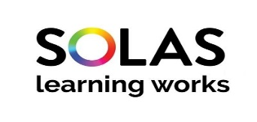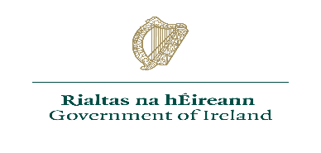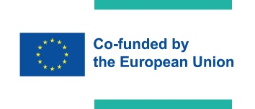

Section 2 – Financial Details
Section 1 – Part 2
Tax Clearance (Please attach details of your current Tax Clearance Access with this application)
Tax Registration Number:
Tax Clearance Certificate Number:
CHY Number (if applicable):
Bank Details
Name of Bank:
Address of Bank
Sort Code: |  |  | Account Number:
IBAN:

Financial Details of Project Initiative
Cost of Project: |  | €
Grant Request (the grant amount sought) |  | €
If the total cost of the project is greater than the amount of the grant sought, please outline where and how the balance of funding will be secured:
Estimated costs for each of the following where applicable :
Green Projects | Learner Assistance Fund | Participation of priority/target cohorts | Support for Refugee Support Groups
€ | € | € | €
Equality Awareness | Participation of ‘Adult Literacy for Life Strategy’ target cohorts e.g. unmet literacy needs, access to technology and devices and community access to WiFi/broadband. | Pre development phase community groups supporting marginalised groups.
€ | € | € | €
Expenditure must not be used for any pay costs or costs of a recurring nature; Capital threshold is based on the cost of any item more than €3,000 including VAT. Capital items cannot be funded through this grant. Items/services must be sourced according to government procurement policies and procedures and quotations supplied where applicable.
Quotations and Procurement Requirements:
In order to process your application in full please ensure to submit quotes with the completed application form. The following procurement requirements will apply:
• under €5000 - one written quote,
• €5,001 - €15,000 - three written quotes
• €15,001 - €25,000 - five written quotes
*note; if purchasing 12 identical items and each item costs €500 then three written quotes are required.

Section 3 - Proposal Details
Statement of proposal
Please provide a synopsis of the target group and the category under which you are applying for this funding: (Please refer to Reach Fund 2023 Guidelines)

Section 3 - Proposal Details - continued
Please include any additional information regarding the funding categories and the target group(s) you wish to include in this application:
Please provide information demonstrating how this funding intends to mitigate against educational disadvantage for the cohort you are working with:
Please clarify how this funding will support your learners to achieve positive outcomes as a result of this support:
How will the benefits of this funding be measured?
Please provide information on how this project represents value for money?
Will this project duplicate work of an existing community development organisation? Yes/No
Please indicate what steps the project has taken to ensure avoiding duplication with existing community development activities and other services in the area.

Section 4 – Submission Details
I declare on behalf of: insert organisation name
That I have the appropriate authority to make this submission for funding. This request for funding form is fully completed and the information provided is a full and accurate account of how the funding (if allocated) will be used in 2023.

Signature (1) |  | Print name
Position in organisation |  | Date

Signature (2) |  | Print name
Position in organisation |  | Date

Closing date for receipt of applications: 4pm on 16th May, 2023

