REACH FUND 2022
(FORMERLY KNOWN AS MAEDF -MITIGATING AGAINST EDUCATIONAL DISADVANTAGE FUND)
FUNDING APPLICATION FORM
Note: Please submit completed applications by 5pm on Tuesday 6th September, 2022 .
Pay costs or costs of a recurring nature are not permitted
Section 1. Community Group/Project Information

Section 1 - Part 1
Community Group/Project Details
Name of Community Group:
Title of proposed project:
Details of Contact Person
Contact Person: |  |  |  | Role in organisation
Address:
Email: |  |  | Telephone
Funding
Have you received REACH funding from another source in 2022? |  |  |  |  |  |  | Yes ☐ No ☐
If yes, please answer the following questions
Source(s) of this funding: |  |  |  | Intended purpose of this funding:

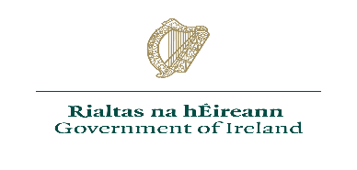
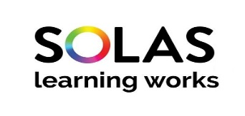

Section 2 – Financial Details
Section 1 – Part 2
Tax Clearance (Please attach details of your current Tax Clearance Access with this application)
Tax Registration Number:
Tax Clearance Certificate Number:
CHY Number (if applicable):
Bank Details
Name of Bank:
Address of Bank
Sort Code: |  |  | Account Number:
IBAN:

Financial Details of Project Initiative
Cost of Project: |  | €
Grant Request (the grant amount sought) |  | €
If the total cost of the project is greater than the amount of the grant sought, please outline where and how the balance of funding will be secured:
Estimated costs for each of the following where applicable:
Green Projects | Learner Assistance Fund | Participation of priority/target cohorts | Support for Refugee Support Groups
€ | € | € | €
Equality Awareness | Participation of ‘Adult Literacy for Life Strategy’ target cohorts e.g., unmet literacy needs, access to technology and devices and community access to Wi-Fi/broadband. |  | Pre-development phase community groups supporting marginalised groups.
€ | € |  | €
Expenditure must not be used for any pay costs or costs of a recurring nature. Capital items cannot be funded through this grant. Capital threshold is based on the cost of any item more than €1,000 excluding VAT (€1,230 including VAT). Items/services must be sourced according to government procurement policies and procedures.

Quotations and Procurement Requirements:
In order to process your application in full please ensure to submit quotes with the completed application form. The following procurement requirements will apply:
• under €5000 - one written quote,
• €5,001 - €15,000 - three written quotes
• €15,001 - €25,000 - five written quotes

Section 3 - Proposal Details
Statement of proposal
Please provide a synopsis of the target group and the category under which you are applying for this funding: (Please refer to Reach Fund 2022 Guidelines)

Section 3 - Proposal Details - continued
Please include any additional information regarding the funding categories and the target group(s) you wish to include in this application:
Please provide information demonstrating how this funding intends to mitigate against educational disadvantage for the cohort you are working with:
Please clarify how this funding will support your learners to achieve positive outcomes as a result of this support:
How will the benefits of this funding be measured?
Please provide information on how this project represents value for money?
Will this project duplicate work of an existing community development organisation? Yes/No
Please indicate what steps the project has taken to ensure avoiding duplication with existing community development activities and other services in the area.

Section 4 – Submission Details
I declare on behalf of: insert organisation name
That I have the appropriate authority to make this submission for funding. This request for funding form is fully completed and the information provided is a full and accurate account of how the funding (if allocated) will be used in 2022.

Signature (1) |  | Print name
Position in organisation |  | Date

Signature (2) |  | Print name
Position in organisation |  | Date

Applications to be submitted to:
Mayo Sligo Leitrim
Mairtin O’Morain Anna-Marie Kinsella Paul Hamilton
MSLETB MSLETB MSLETB
Lucan Street Quay Street St. George’s Terrace
Castlebar Sligo Carrick-on-Shannon
F23 FW70 F91 XH96 N41 W2X7
mairtinomorain@msletb.ie annamariekinsella@msletb.ie paulhamilton@msletb.ie

Closing date for receipt of applications: 5pm on 6th September, 2022

