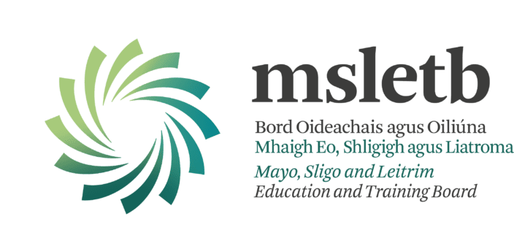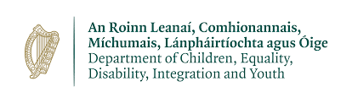

MSLETB UBU Your Place Your Space – Call For Service
Introduction:
MSLETB is seeking an organisation with experience of providing services to young people, to deliver a youth service to young people in the Erris region. This new project is being established in line with the UBU Your Place Your Space scheme funded by the Department of Children, Equality, Disability, Inclusion & Youth (DCEDIY).

The mission of the UBU Your Place Your Space Funding Scheme is:
“To provide out-of-school supports to young people in their local communities to enable them to overcome adverse circumstances and achieve their full potential by improving their personal and social development outcomes.”

The organisation MSLETB is seeking should:
- Exemplify good practice in relation to vision, methodologies, governance, compliance, programme design, delivery and evaluation
- Be experienced in working with targeted young people aged 10-24 years with complexity of needs, using non-formal educational methodology

- Operate in an out-of-school setting, including evenings, weekends and school holidays

- Understand the nature and needs of young people living in disadvantaged communities and offer appropriate responses
- Able to devise and measure effective responses to the needs of the target group
- Be committed to on-going sharing of learning and collaboration

Background:
Education and Training Boards (ETB)
Education and Training Boards (ETBs) have a role in the development, implementation and strengthening of policy and service provision for children and young people, including youth work provision, which will achieve better outcomes for children and young people. This is in line with the statutory responsibility of the ETBs in matters of youth work policy implementation and additionally covers the ETB role in the broader policy objectives of DCEDIY as it relates to youth policy.

The Education and Training Boards Act, 2013 states that the functions of ETBs with regard to youth work are to:

- Support the provision, coordination, administration and assessment of youth work services in its functional area and provide such information as may be requested by the Minister for Children and Youth Affairs in relation to such support; and assess whether the manner in which it performs its functions is economical, efficient and effective.

The Education and Training Boards Act goes on to state (Section 10(6)) that “youth work” has the same meaning as it has in the Youth Work Act 2001.

Department of Children, Equality, Disability, Integration & Youth (DCEDIY)
The DCEDIY is the principal Department to whom ETBs report in relation to their youth work functions. It has a mandate in relation to policy and service provision for children and young people. The Department comprises a number of interrelated strands, including the direct provision of universal and targeted services, and working to achieve the harmonisation of relevant policy and provision across Government so as to improve outcomes for children, young people and families.
The DCEDIY strategic and operational objectives are informed by the following:
• Better Outcomes, Brighter Futures – The national policy framework for children and young people, 2014-2020,
• National Youth Strategy, 2015-2020,
• Recommendations of the Value for Money and Policy Review of Youth Programmes, 2014 (VFMPR) – see below,
• UBU Your Place Your Space funding Scheme 2020,
• National Quality Standards Initiatives (National Quality Standards Framework for the Youth Work Sector/National Quality Standards for Volunteer-led Youth groups),
• LGBTI+ National Youth Strategy 2018-2020,
• Directives and circulars pertaining to the management of public funds, accountability and by needs identified by ETBs locally.

UBU Scheme:
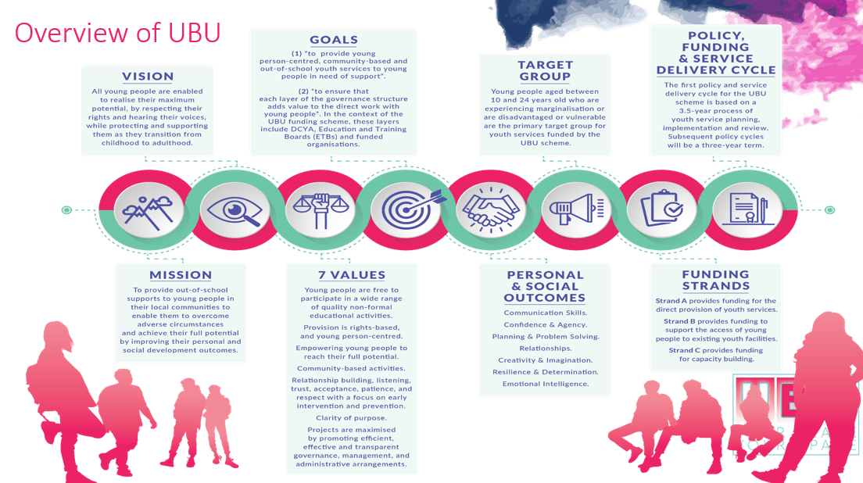
Area Profile Needs Assessment and Service Requirements (APNASR)
This tool supports an ETB in identifying and prioritising the needs of young people who fall within the defined target group for UBU Your Place Your Space scheme. The APNASR requires an ETB to understand, integrate and analyse different sources of quantitative and qualitative information. The data sources have been selected because they are nationally available and free to access, helping to establish a consistency of focus across UBU Your Place Your Space. The successful organisation must work with the target groups identified through this process.

Service Brief:
The approach offered by the successful organisation must have at its core the following elements:
- Develop new and innovative programmes and interventions to meet the needs and interests of the young people identified in the catchment area.
- Operate primarily on late evenings, on weekends and during school holidays.
- Focus on developing culturally appropriate interventions in response to the needs of the young people targeted by the Project. This requires dynamic and creative approaches to working with such diverse groups of young people.
- Engage the young people in the co-design of the Project and the programmes on offer.
- Ensure a minimum of 80% of the young people (aged 10 to 24 years) accessing the service are within the target group requiring support or at significant risk. Additionally, there will be scope and an expectation on the Provider to develop and respond to any new and emerging needs as may be identified by ETB.
- Ensure a minimum of 70% of the service effort will be on direct service delivery with young people.
- Engage qualified, skilled staff utilising evidenced based interventions and adopting the Logic Model for programme planning.
- Give priority to developing and enhancing interagency collaborations with other providers of services for young people operating in the identified area.
- Regularly evaluate the impact of the youth work interventions and evidence the improved outcomes for young people.
Funding:
A budget of €120,000 per annum has been made available under the UBU Your Place Your Space funding scheme for this new youth service. The budget will support direct and indirect costs associated with delivering the youth service in line with the UBU Your Place Your Space Policy & Operating Rules, Financial Requirements outlined in Chapter 7.
Location:
MSLETB has identified Belmullet as the location for the new youth service base with outreach in Eachléim and Rossport/Cornboy. The map below illustrates the catchment area for the new youth service. This was based on evidence gathered through the APNASR process 2019 and on consultations/research undertaken in 2021.

Social Profile: Erris region
Located on the extreme north-western edge of Connaught, Erris is a vast rural part of Mayo. It is one of 3 areas that comprise the Mayo Gaeltacht. Erris is an area of very high deprivation that has a total population of 8,278, of whom 1,499 are aged between 10-24 years. Erris comprises 16 adjacent areas (EDs), centred around the principal town of Belmullet. These 16 EDs make up five natural parishes in the Erris area which, combined, are slightly larger in size than county Dublin. These 5 parishes have HP Deprivation Index Scores between -10.13 and -17.85, with 70% of SAs between -10 and -22.27. All 18 of the primary schools in the area, along with all three of the post-primary schools, are designated as disadvantaged under DEIS.
Due to the very large size of the service catchment area, the new UBU service will be required to operate from a base in the principal town of Belmullet, but providing also services in two outreach areas - one in Eachléim, the other in the Rossport / Cornboy area.

Strengths:
- Buy-in from a range of agencies and networks, with a huge commitment from the community to get behind a new project, increasing the likelihood of a rapid establishment and successful rollout of a project.
- Strong history of interagency collaboration in the area which the youth service will be able to tap into once established.
- Commitment from Mayo County Council and others to provide suitable project base and outreach locations.
- Mindspace Mayo, a free and confidential youth mental health support service for young people aged 15-25 years of age, operate an outreach service in Belmullet town one day per week.
- MSLETB have recently been selected for participation in the Local Creative Youth Partnership national initiative. This initiative will be closely linked with MSLETB's youth work function, and will provide the opportunity for collaboration in relation to creative programmes for vulnerable, marginalised young people.
- Irish language – opportunities to work in tandem with Irish language planning officer.
- There is an active volunteer-led Youth Disability Network that is working towards accessing education, training and employment for young people with disabilities living in the area.

Challenges
- High levels of deprivation: The 5 areas that comprise Erris have deprivation between -10.13 and -17.85, with 70% of SAs at deprivation levels between -10 and -22.27 (HPDI).
- Zero existing youth service provision: There is a total absence of youth services or related provision, gravely affecting the ability to support vulnerable, marginalised young people.
- Extreme remoteness and distance from services: Located on the extreme north-western edge of Connaught, Erris (933 sq.km) is larger than county Dublin (922sq.km). Young people in Erris requiring additional supports often do not receive such supports, due to the long distances involved (e.g. Belmullet to Castlebar, 76km). Parents often struggle to make it home in time to bring young people to activities, particularly challenging for families on low income and with one car in the household.
- Issues faced by young people: There are high levels of mental health difficulties and social anxiety amongst young people. Arising from deprivation and remoteness, many are forced to move elsewhere for education, training and employment. Acute lack of opportunities for self-development, positive socialisation and self-development, with high rates of alcohol misuse in young people.
- The Erris region had one of the highest incidences of COVID-19 in January 2021, which sadly resulted in a number of deaths. The true impact of the COVID-19 pandemic on young people is not yet fully known but there has been a marked increase in young people becoming more isolated in their own homes and local communities and presenting with mental health difficulties and social anxiety.

Response:
The UBU service required will respond to the needs of:

Target Group 1: Young people aged 16-18 years experiencing marginalisation and social and cultural disadvantage in Belmullet and surrounding areas, of all genders. Specifically young people who are vulnerable and at risk of not flourishing and of developing associated difficulties in the areas of mental health, substance misuse and low educational attainment:
That young people would enhance their confidence and agency, communication skills and relationships with peers, adults and the wider community, through developmental programmes provided in a safe and supportive environment.

Target group 2: Young people in Junior Cycle years (i.e. 13-16 year olds approx.) who are vulnerable and experiencing marginalisation in the Belmullet and surrounding areas, of all genders; &
Target group 3. Young people in Junior Cycle years (i.e. 13-16 year olds approx.) who are vulnerable and experiencing marginalisation in the Eachléim and surrounding areas, of all genders; &
Target group 4. Young people in Junior Cycle years (i.e. 13-16 year olds approx.) who are vulnerable and experiencing marginalisation in the Rossport / Cornboy and surrounding areas, of all genders:
That young people would enhance their confidence and agency, resilience and determination and relationships with peers, adults and the wider community, through developmental programmes provided in a safe and supportive environment.

Target group 5. Young people in 5th and 6th class (i.e. approx. 10-13 years old) in the Belmullet and surrounding areas of all genders, experiencing marginalisation whose circumstances limit their opportunities and are at risk of not flourishing; &
Target group 6. Young people in 5th and 6th class (i.e. approx. 10-13 years old) in the Eachléim and surrounding areas, of all genders, experiencing marginalisation whose circumstances limit their opportunities and are at risk of not flourishing; &
Target group 7. Young people in 5th and 6th class (i.e. approx. 10-13 years old) in the Rossport / Cornboy and surrounding areas, of all genders, experiencing marginalisation whose circumstances limit their opportunities and are at risk of not flourishing:
That young people would enhance their confidence and agency, communication skills and relationships with peers, adults and the wider community, through developmental programmes provided in a safe and supportive environment.

The identified needs are situated within the UBU scheme, directly relating to the following outcome areas:
Relationships / Resilience and determination / Confidence and agency / Communication skills

General Considerations:
The UBU youth service will operate from a base in Belmullet with two outreach services in Eachléim and Rossport/Cornboy.

Factors for consideration:
- Given the profile of the Erris region outlined above, young people most in need should be prioritised. The issue of rural isolation and the lack of services is a key consideration in responding to the needs of young people in this area.
- The aim of the project is to provide out-of-school opportunities for young people that are fun, recreational, developmental, educational and youth-centred.
- Promotion of the service will be critical to the success of the project
- New service will provide safe and accessible spaces for young people in the identified areas of Erris, and will develop innovative approaches to engaging the target groups identified in the MSLETB Call for Service
- The service needs to be delivered at times and in venues which are suitable for young people, including the evenings, weekends and school holidays.
- Interventions with the target groups outlined above are likely to include one-to-one supports, particularly in the earlier stages of engagement, as well as work in small groups. Other interventions such as small and large group work as well as advocacy and support in accessing other relevant services may also be included.
- The service will need to work in collaboration with other organisations in the area in order to utilise appropriate referral pathways, including to facilitate progression to education, training and employment.

The high level of deprivation, combined with non-existent youth and related services, extreme remoteness and range of issues faced by young people such as rural isolation, mental health difficulties, anxiety and alcohol misuse make Erris the area of greatest need of a new UBU service in MSLETB’s region.
Selection Process for the New Project Preferred Provider
A preferred provider will be identified through the following selection process:
• Stage 1 – MSLETB publicly advertise the Scheme in early August 2021, asking interested parties to apply according to the steps outlined in the Information Pack. The closing date for receipt of fully completed Submission Application Form is 5pm, Friday 3rd September 2021.
NOTE: Only organisations who have fully completed the Submission Application Form and answered YES to all 12 UBU Eligibility Criteria will be considered.
• Stage 2 – Analysis of Submissions received and shortlisting for interview process by MSLETB.
• Stage 3 – Interviews, consisting of a formal presentation by the applicant organisation are scheduled for Friday 10th September 2021.
• Stage 4 – Decision is reached by MSLETB interview panel, further discussions may be held with selected preferred provider regarding their service offer and MSLETB’s requirements. MSLETB will inform DCEDIY that the process is complete and that the identified organisation is been recommended as the preferred provider.
• Stage 5 – Once confirmed by the DCEDIY the successful preferred provider will be asked to make a formal UBU application for funding to MSLETB. If in order, MSLETB will make a recommendation to DCEDIY as per UBU Policy and Operating Rules. Following DCEDIY approval, a letter of allocation can issue to the funded organisation.
• Stage 6 – A Service Level Agreement will be issued and signed by the successful funded organisation and MSLETB. The Funded Organisation undertakes phase one of the New Youth Service, hiring staff, providing orientation training, securing premises etc.
• Stage 7 – New Youth Service launch & the UBU Your Place Your Space Performance Oversight & Engagement Framework will commence.
In compliance with the Data Protection Act 2018, the General Data Protection Regulation, and guidance from the Data Protection Commission, any personal data you give us in connection with this application will be kept securely and only used for the purposes of assessment (including shortlisting and interviewing), general administration, reporting and to fulfil our other legal obligations. When we no longer have any lawful basis for retaining it, it will be destroyed/deleted. Under the Freedom of Information (FOI) Act 2014, any information we receive in our dealings with you can potentially be released to the general public on request. Under s8 of the FOI Act, a list of all grants over €10,000 will be published on our website on an annual basis.
Details Stage 1: Return of Submission Application Form
Fully completed Submission Application Form is to be returned electronically by 5pm, Friday 3rd September 2021 to youthwork@msletb.ie.
It is the responsibility of each respondent to ensure that the Submission Application Form reaches MSLETB before the deadline. Submission Application Forms sent to any other address (other than the one indicated above) or received after the deadline will be deemed invalid.
Details Stage 2: Analysis of Submissions received and shortlisting for interview process by MSLETB.
UBU Your Place Your Space Eligibility Criteria
The following 12 questions will be used to assess the organisations eligibility to proceed with an application under the UBU Your Place Your Space scheme. All applicants must be in a position to answer Yes to all of the Eligibility Criteria questions to be shortlisted. The ETB reserves the right to ask for evidence relating to each Eligibility Criteria.

No | Eligibility Criteria | Yes | No
1 | Do you have a Memorandum and Articles of Association or a Constitution, which outlines the projects governance structure, and a list of the Board of Directors?
2 | Are you willing to provide the financial records and related materials in respect of the Grant provided for auditing and inspection purposes by DCEDIY, ETB and/or its designated bodies, or the Comptroller and Auditor General?
3 | Are you willing to fulfil the UBU Your Place Your Space scheme rules?
4 | Are you willing to comply with the DPER circular 13/2014 and have you the appropriate systems in place to ensure compliance?
5 | Are you compliant with the Children First Act 2015?
6 | Do you have appropriate levels of insurance in place on all the project’s assets, public liability and employer’s liability? (The levels of insurance required cover: €12.7 million for employer’s liability insurance; and €6.5 million for public liability insurance.)  AND  Will your organisation specifically indemnify DCEDIY and MSLETB.
7 | Have you a recruitment and selection process in place that is compliant with the relevant legislation inclusive of Garda Vetting of adults working with young people in a paid and voluntary capacity in line with the National Vetting Bureau (Children and Vulnerable Persons) Acts 2012-2016.
8 | Have you an Organisational Health and Safety Statement and Policy in place and have you a listed person as Health & Safety Officer?
9 | Have you accounts that are audited on a calendar year by external auditors and have available the 2020 signed audited accounts?
10 | Is your organisation fully compliant with all its relevant governance code/s? (e.g. companies ltd by guarantee with no share capital, public bodies, charitable bodies, cooperatives).
11 | Is your organisation willing to participate in the trialling of sample services and tools as directed by ETBs and DCEDIY to support development of best practice and evaluation initiatives?
12 | Is your organisation willing to report directly to the ETB on work with young people, targets achieved and financial matters?

Shortlisting:
Once the ETB has assessed that the respondent is in a position to answer YES to all 12 eligibility criteria the following categories are scored. Please Note: respondents must meet a minimum score under each category in order to be shortlisted.

Category |  | Weighting | Maximum Score | Minimum Score Required
1 | Response to identification of need/Impact | 20% | 200 | 120
The degree to which the submission demonstrates:
- A plan which addresses the needs identified by the ETB
- The suitability of the methods the respondent intends to deploy to engage the target groups of young people identified by the ETB
- The projected numbers of young people to be engaged
- Ability to facilitate young peoples involvement in the co-design of the programmes/project
2 | Demonstrated knowledge and track record: Practice & Delivery | 25% | 250 | 150
The degree to which the submission has demonstrated:
- Knowledge and track record of working through a non-formal educational approach with the target groups outlined in the Call For Service.
- Knowledge of the local area or working in similar areas with similar target groups,
- Demonstrable knowledge and track record in addressing the needs of the target groups
- Demonstrable capacity and capability to implement youth work approaches
- Demonstrated commitment to the vision, mission, goals & values of UBU Your Place Your Space

3 | Demonstrated knowledge and track record: Governance & Oversight | 25% | 250 | 150
The degree to which the submission has demonstrated a capacity and ability to deliver the proposed on the operational and governance requirements:
- Evidence of an ability to deliver on the governance requirements through appropriate structures, systems and policies including but not limited to, Health and Safety Policy, a written child protection, welfare and safeguarding policy and related procedures, Garda Vetting Policy, Volunteer Policy and Procedures., Drug and Alcohol Policy and Procedures.
- Financial Management Procedures, Human Resources (HR) policy and procedures, Data Protection policy, Risk Management policy and procedures.
- Evidence should demonstrate the organisations ability to implement all relevant sections of the Companies Act 2014, FRS 102 (mandatory) and to prepare where possible for Statement of Recommended Practice (SORP) compliant accounts.
- Quality of the risk assessment and appropriateness of the actions to address the risks identified,
- Experience of monitoring and evaluation systems in human services.

4. | Value For Money/Additionality | 10% | 100 | 60
The degree to which the submission has demonstrated:
- Clear, realistic budget with supporting rationale,
- The degree to which the applicant can demonstrate that they can bring additional resources to this application (including, but not limited to):
• Relationships with key agencies operating in the geographic/issue area,
• Additionality offered from existing services offered by the applicant organisation,
• Access to premises, equipment, volunteers and other resources,
• Access to administration and management support.
5 | Implementation | 20% | 200 | 120
The degree to which the submission has demonstrated:
- A clear plan for each element of the project establishment and implementation
- A clear timeframe for each stage of project establishment and implementation
- A clear plan for managing the delivery, reporting and financial management requirements

Details Stage 3: Interview
Interviews consisting of a formal presentation by respondents are scheduled to take on Friday 10th September 2021. The MSLETB recommendation of a preferred provider will be based upon assessment of both the Submission Application Form AND the interview process. Both the Submission Application Form and the interview will be marked under the 5 categories outlined below:
- Response to identification of need/impact
- Demonstrated knowledge and track record: Practice & Delivery
- Demonstrated knowledge and track record: Governance & Oversight
- Value For Money/Additionality
- Implementation
Please Note: In order to be considered for recommendation by MSLETB as the preferred provider respondents must attain the minimum score in each category.
The formal presentation which is part of the interview process must address the 5 categories indicated in the scoring system.
Appeals Process
Final decision with regard to the selected provider rests with DCEDIY. As such respondents to the Call for Service can only appeal the outcome with the ETB based on procedural issues relating to the application and appraisal process. All appeals must be submitted within one week of the date on the notification of the outcome correspondence.

Appeals should be submitted to:
- youthwork@msletb.ie placing “UBU Call for Service Appeal” in the subject line. It is the responsibility of the appellant organisation to ensure the appeal is received.
- As indicated above appeals can only be based on procedural issues related to the process as outlined in the MSLETB Call for Service.
- Appeals will only be accepted from the lead applicant.
- Appeals submitted to MSLETB after the appeal date will not be considered.
- The appeals panel will not include any member of the original assessment group.
- The appeal process will be conducted within a two-week period from the date of receipt of the appeal.
- The appeals panel will review the appeal and make a recommendation to the Chief Executive of MSLETB. This recommendation will form the basis for any decisions made with regard to the recommendation of preferred provider to DCEDIY.
- MSLETB will inform the appellant organisation of the outcome.

